**An Application on Home Hospitalization using Cloud Computing**

*Report submitted to the SASTRA Deemed to be University as the requirement for the course*

**Sai Kiruthika S**

**(Reg.No.: 121015085, Information Technology)**

**Iswariya K**

**(Reg.No.: 121015041, Information Technology)**

**Pavithra S**

**(Reg.No.: 121015073, Information Technology)**

**December2021**



**SCHOOLOFCOMPUTING**

**THANJAVUR,TAMILNADU,INDIA–613401**



**SCHOOL OF COMPUTING THANJAVUR – 613 401**

**Bonafide Certificate**

This is to certify that the report titled “**An Application on Home Hospitalization using Cloud Computing**“ submitted as a requirement for the course, **MINI PROJECT** for B.Tech. is a bonafide record of the work done by **Mr. *****(Reg. No.120******,Programme**) (Names with register no in bracket of all members in ascending order of Register no.) during the academic year 2020-21, in the School of Computing, under my supervision.

### Signature of Project Supervisor : Name with Affiliation :

**Date :**

Mini Project *Viva voc*e held on

### Examiner 1 Examiner 2

**ABSTRACT**

### In recent years, the planet has witnessed a big increase within the range of elderly who usually suffer from chronic diseases, and has witnessed in recent months a significant unfold of the new coronavirus (COVID-19), which has led to thousands of deaths, particularly among the older and folks that suffer from chronic diseases. Coronavirus has additionally caused several issues in hospitals, wherever these are not any longer able to accommodate an oversized number of patients. This virus has additionally begun to unfold between medical and paramedical groups, and this causes a major risk to the health of patients staying in hospitals. To scale back the unfold of the virus and maintain the health of patients who want a hospital keep, home hospitalization is one of the most effective solutions. This project proposes a home hospitalization application supported by Cloud computing. The application on home hospitalization using Cloud computing software covers the services that unify and simplify the work of healthcare professionals as well as their interactions with patients. There is always the wide choice of features that can be included in the system. Moreover, the most important thing they are created to streamline various procedures that meet the needs of all the users. The hospital management system feature list is concentrated on providing the smooth experience of patients, staff and hospital authorities. It might seem that their expectations differ; they still are covered by components of the hospital information system. It is also known for the constant and rapid changes to improve the efficiency of medical services and satisfaction of the patients. Using this algorithm we developed for computerizing hospitals to manage patient’s information more efficiently and save time in serving patients in limited time. Using this system detail of doctor they consulted and disease they are suffering form, updated to database. Using patient management system application hospitals can easily manage patient’s data and helps in analyzing patient’s visits and retrieving old data. Each and every record will be stored in cloud storage .The results of evaluation have shown nice acceptance of this method by patients and doctors alike.

### KEYWORDS- cloud computing, home hospitalization, covid-19

**Table of Contents**

**Title**

|  |
| --- |
| Bonafide Certificate |
| AcknowledgementList of Figures  List of Tables  Abstract |
| 1. Summary of the basepaper |
| 1. Merits and Demerits of the basepaper |
| 1. Source Code |
| 1. Snapshots |
| 1. Conclusion and Future Plans |
| 1. References |
| 1. Appendix –Base Paper |

**Summary of the base paper:**

As of late, the world has seen a critical expansion in the quantity of old who regularly experience the ill effects of on-going infections, and has seen as of late a significant spread of the new (COVID-19), which has prompted a large number of passing’s, particularly among the old and individuals who experience the ill effects of constant illnesses. Covid has additionally caused numerous issues in clinics, where these are not; at this point ready to oblige an enormous number of patients. This infection has likewise started to spread among clinical and paramedical groups, and this makes a significant danger the strength of patients remaining in clinics. To diminish the spread of the infection and keep up the wellbeing of patients who need an emergency clinic remain, home hospitalization is a standout amongst other potential arrangements. This paper proposes a home hospitalization framework dependent on the Internet of Things (IoT), Fog registering, and Cloud processing, which are among the main innovations that have added to the improvement of the medical care area in a critical manner. These frameworks permit patients to recuperate and get treatment in their homes and among their families, where persistent wellbeing and the hospitalization room ecological state are checked, to empower specialists to follow the hospitalization cycle and make suggestions to patients and their directors, through observing units and versatile applications produced for this reason. The consequences of assessment have demonstrated extraordinary acknowledgment of this framework by patients and specialists the same.

**Merits:**

**Source Code**

Index.php

<?php ob_start();

include "source/include/db_connect.php";

?>

<!DOCTYPE html>

<html lang="en">

<head>

<meta charset="utf-8">

<meta http-equiv="X-UA-Compatible" content="IE=edge">

<meta name="viewport" content="width=device-width, initial-scale=1">

<meta name="description" content="">

<meta name="author" content="">

<title>HealthCare Monitoring System</title>

<!-- Bootstrap Core CSS -->

<link href="bootstrap/css/bootstrap.min.css" rel="stylesheet">

<!-- Font Awesome CSS -->

<link href="css/font-awesome.min.css" rel="stylesheet">

<!-- Custom CSS -->

<link href="css/animate.css" rel="stylesheet">

<!-- Custom CSS -->

<link href="css/style.css" rel="stylesheet">

<!-- Custom Fonts -->

<link href='http://fonts.googleapis.com/css?family=Lobster' rel='stylesheet' type='text/css'>

<!-- Template js -->

<script src="js/jquery-2.1.1.min.js"></script>

<script src="bootstrap/js/bootstrap.min.js"></script>

<script src="js/jquery.appear.js"></script>

<script src="js/contact_me.js"></script>

<script src="js/jqBootstrapValidation.js"></script>

<script src="js/modernizr.custom.js"></script>

<script src="js/script.js"></script>

</head>

<body>

<!-- Start Logo Section -->

<section id="logo-section" class="text-center">

<div class="container">

<div class="row">

<div class="col-md-12">

<div class="logo text-center">

<h1>Healthcare Monitoring System</h1>

<!-- <span>Your Business Field</span> -->

</div>

</div>

</div>

</div>

</section>

<!-- End Logo Section -->

<!-- Start Main Body Section -->

<div class="mainbody-section text-center">

<div class="container">

<div class="row">

<div class="col-md-3">

<div class="menu-item light-red">

<a href="#about-modal" data-toggle="modal">

<i class="fa fa-user"></i>

<p>About Us</p>

</a>

</div>

<div class="menu-item blue">

<a href="#portfolio-modal" data-toggle="modal">

<i class="fa fa-magic"></i>

<p>Feature</p>

</a>

</div>

<div class="menu-item green">

<a href="source/admin/login.php">

<i class="fa fa-cogs"></i>

<p>Admin</p>

</a>

</div>

</div>

<div class="col-md-6">

<!-- Start Carousel Section -->

<div class="home-slider">

<div id="carousel-example-generic" class="carousel slide" data-ride="carousel" style="padding-bottom: 30px;">

<!-- Indicators -->

<ol class="carousel-indicators">

<li data-target="#carousel-example-generic" data-slide-to="0" class="active"></li>

<li data-target="#carousel-example-generic" data-slide-to="1"></li>

<li data-target="#carousel-example-generic" data-slide-to="2"></li>

<li data-target="#carousel-example-generic" data-slide-to="3"></li>

</ol>

<!-- Wrapper for slides -->

<div class="carousel-inner">

<div class="item active">

<img src="images/1.png" class="img-responsive" alt="" style="height:312px;">

</div>

<div class="item">

<img src="images/2.jpg" class="img-responsive" alt="" style="height:312px;">

</div>

<div class="item">

<img src="images/3.jpg" class="img-responsive" alt="" style="height:312px;">

</div>

<div class="item">

<img src="images/4.jpg" class="img-responsive" alt="" style="height:312px;">

</div>

</div>

</div>

</div>

<!-- Start Carousel Section -->

<div class="row">

<div class="col-md-6">

<div class="menu-item color responsive">

<a href="source/doctor/login.php" data-toggle="modal">

<i class="fa fa-heart"></i>

<p>Doctor</p>

</a>

</div>

</div>

<div class="col-md-6">

<div class="menu-item light-orange responsive-2">

<a href="source/pharmacy/login.php" data-toggle="modal">

<i class="fa fa-user"></i>

<p>Pharmacy</p>

</a>

</div>

</div>

</div>

</div>

<div class="col-md-3">

<div class="menu-item light-red">

<a href="contact.php">

<i class="fa fa-envelope-o"></i>

<p>Contact</p>

</a>

</div>

<div class="menu-item color">

<a href="#testimonial-modal" data-toggle="modal">

<i class="fa fa-comment-o"></i>

<p>Testimonial</p>

</a>

</div>

<div class="menu-item blue">

<a href="source/patient/index.php" data-toggle="modal">

<i class="fa fa-users"></i>

<p>Patient</p>

</a>

</div>

</div>

</div>

</div>

</div>

<!-- End Main Body Section -->

<!-- Start Copyright Section -->

<div class="copyright text-center">

<div class="container">

<div class="row">

<div class="col-md-12">

<div>Patient Management</div>

</div>

</div>

</div>

</div>

<!-- End Copyright Section -->

<!-- Start Portfolio Section -->

<div class="section-modal modal fade" id="portfolio-modal" tabindex="-1" role="dialog" aria-hidden="true">

<div class="modal-content">

<div class="close-modal" data-dismiss="modal">

<div class="lr">

<div class="rl">

</div>

</div>

</div>

<div class="container">

<div class="row">

<div class="section-title text-center">

<h3>Features</h3>

</div>

</div>

<div class="row">

<div class="col-md-12"><br/><br/>

<div class="about-text">

<p style="font-size:15px;line-height:2em;">Due to diversity, heterogeneity and complexity of the existing healthcare structure, providing suitable healthcare services is a complicated process. This work describes the conceptual design of an e-healthcare system, which implements integration strategies and suitable technologies that will handle the interoperability problem among its essential components. In this paper we proposed an ID3 Decision Tree Algorithm because Decision trees are powerful and popular algorithm for classification and prediction. Decision trees represent rules, which can be understood by humans and used in knowledge system such as database. Decision trees classify instances or examples by starting at the root of the tree and moving through it until a leaf node. A decision tree is a flow-chart-like structure, where each internal (non-leaf) node denotes a test on an attribute, each branch represents the outcome of a test, and each leaf (or terminal) node holds a class label. Using this algorithm we developed for computerizing hospitals to manage patient's information more efficiently and save time in serving patients in limited time. Using this system details of every patient who visited hospital are updated and there details of tests, tablets and amount they paid and doctor they consulted and disease they are suffering form, next visit timings are updated to database. Using patient management system application hospitals can easily manage patient's data and helps in analyzing patients visits and retrieving old data.</p>

</div>

</div>

</div><!-- /.row -->

</div>

</div>

</div>

<!-- End Portfolio Section -->

<!-- Start About Us Section -->

<div class="section-modal modal fade" id="about-modal" tabindex="-1" role="dialog" aria-hidden="true">

<div class="modal-content">

<div class="close-modal" data-dismiss="modal">

<div class="lr">

<div class="rl">

</div>

</div>

</div>

<div class="container">

<div class="row">

<div class="section-title text-center">

<h3>About Us</h3>

</div>

</div>

<div class="row">

<div class="col-md-12"><br/><br/>

<div class="about-text">

<p style="font-size:15px;line-height:2em;">Due to diversity, heterogeneity and complexity of the existing healthcare structure, providing suitable healthcare services is a complicated process. This work describes the conceptual design of an e-healthcare system, which implements integration strategies and suitable technologies that will handle the interoperability problem among its essential components. In this paper we proposed an ID3 Decision Tree Algorithm because Decision trees are powerful and popular algorithm for classification and prediction. Decision trees represent rules, which can be understood by humans and used in knowledge system such as database. Decision trees classify instances or examples by starting at the root of the tree and moving through it until a leaf node. A decision tree is a flow-chart-like structure, where each internal (non-leaf) node denotes a test on an attribute, each branch represents the outcome of a test, and each leaf (or terminal) node holds a class label. Using this algorithm we developed for computerizing hospitals to manage patient's information more efficiently and save time in serving patients in limited time. Using this system details of every patient who visited hospital are updated and there details of tests, tablets and amount they paid and doctor they consulted and disease they are suffering form, next visit timings are updated to database. Using patient management system application hospitals can easily manage patient's data and helps in analyzing patients visits and retrieving old data.</p>

</div>

</div>

</div><!-- /.row -->

</div>

</div>

</div>

<!-- End About Us Section -->

<!-- Start Testimonial Section -->

<div class="section-modal modal fade contact" id="testimonial-modal" tabindex="-1" role="dialog" aria-hidden="true">

<div class="modal-content">

<div class="close-modal" data-dismiss="modal">

<div class="lr">

<div class="rl">

</div>

</div>

</div>

<div class="container">

<div class="row">

<div class="section-title text-center">

<h3>Client's Speech About Us</h3>

</div>

</div>

<div class="row">

<?php

$qry=mysql_query("select * from contact");

while($row=mysql_fetch_array($qry))

{

?>

<div class="col-md-6">

<div class="testimonial">

<h4><?php echo $row['name']; ?>,<?php echo $row['mobile']; ?></h4>

<div class="speech">

<p><?php echo $row['message']; ?></p>

</div>

</div>

</div>

<?php

}

?>

</div><!--/.row -->

</div>

</div>

</div>

<!-- End Testimonial Section -->

</body>

</html>

Contact.php

<?php ob_start();

include "source/include/db_connect.php";

?>

<!DOCTYPE html>

<html lang="en">

<head>

<meta charset="utf-8">

<meta http-equiv="X-UA-Compatible" content="IE=edge">

<meta name="viewport" content="width=device-width, initial-scale=1">

<meta name="description" content="">

<meta name="author" content="">

<title>Patient Management</title>

<!-- Bootstrap Core CSS -->

<link href="bootstrap/css/bootstrap.min.css" rel="stylesheet">

<!-- Font Awesome CSS -->

<link href="css/font-awesome.min.css" rel="stylesheet">

<!-- Custom CSS -->

<link href="css/animate.css" rel="stylesheet">

<!-- Custom CSS -->

<!-- Custom Fonts -->

<link href='http://fonts.googleapis.com/css?family=Lobster' rel='stylesheet' type='text/css'>

<!-- Template js -->

<script src="js/jquery-2.1.1.min.js"></script>

<script src="bootstrap/js/bootstrap.min.js"></script>

<script src="js/jquery.appear.js"></script>

<script src="js/contact_me.js"></script>

<script src="js/jqBootstrapValidation.js"></script>

<script src="js/modernizr.custom.js"></script>

<script src="js/script.js"></script>

</head>

<body>

<!-- Start Contact Section -->

<div class="container">

<div class="row">

<div class="section-title text-center">

<h3>Contact With Us</h3>

</div>

</div>

<div class="row" style="padding-top: 80px;">

<div class="col-md-12">

<form name="sent" method="post">

<div class="row">

<div class="col-md-6">

<div class="form-group">

<input type="text" name="name" class="form-control" placeholder="Your Name *" id="name" required >

<p class="help-block text-danger"></p>

</div>

<div class="form-group">

<input type="email" name="email" class="form-control" placeholder="Your Email *" id="email" required >

<p class="help-block text-danger"></p>

</div>

<div class="form-group">

<input type="text" name="phone" class="form-control" placeholder="Your Phone *" id="phone" required >

<p class="help-block text-danger"></p>

</div>

</div>

<div class="col-md-6">

<div class="form-group">

<textarea class="form-control" name="message" placeholder="Your Message *" id="message" required ></textarea>

<p class="help-block text-danger"></p>

</div>

</div>

<div class="clearfix"></div>

<div class="col-lg-12 text-center">

<div id="success"></div>

<button type="submit" name="submit" class="btn btn-primary">Send Message</button>

<a href="index.php" class="btn btn-danger">Close</a>

</div>

</div>

</form>

<?php

if(isset($_POST['submit']))

{

extract($_POST);

$cdate=date('d-m-Y');

$qry=mysql_query("insert into contact(cdate,name,email,phone,message)values('$cdate','$name','$email','$phone','$message')");

if($qry)

{

header("location:index.php");

}

else

{

echo "Register Again";

//echo mysql_error();

}

}

if(isset($_POST['submit']))

{

header("location:index.php");

}

?>

</div>

</div>

</div>

</div>

<!-- End Contact Section -->

</body>

</html>

Transfer_record.php

<?php ob_start();

include "../include/db_connect.php";

include "session.php";

?>

<!DOCTYPE html>

<html lang="en">

<head>

<title>Patient Management</title>

<meta charset="utf-8">

<meta name="viewport" content="width=device-width, initial-scale=1.0">

<link href="../css/bootstrap.css" rel="stylesheet">

<link href="../css/style.css" rel="stylesheet">

<link href="../font/css/fontello.css" rel="stylesheet">

<link href='http://fonts.googleapis.com/css?family=Droid+Sans:400,700' rel='stylesheet' type='text/css'></head>

<body>

<div class="navbar">

<div class="navbar-inner">

<a class="btn btn-navbar" data-toggle="collapse" data-target=".nav-collapse"> <span class="icon-bar"></span> <span class="icon-bar"></span> <span class="icon-bar"></span> </a> <img src="../img/user.jpg" alt="" class="img-circle img-responsive" style="margin-top:10px;">

<ul class="nav nav-collapse pull-right">

<li><a class="active" href="patient.php"><i class="icon-picture"></i>User History</a></li>

<li><a href="request.php"><i class="icon-trophy"></i> View Patient Request</a></li>

<li><a href="doctor.php"><i class="icon-picture"></i>Doctors History</a></li>

<li><a href="logout.php"><i class="icon-doc-text"></i> Logout </a></li>

</ul>

<div class="nav-collapse collapse"></div>

</div>

</div>

<div class="container profile">

<h1>Add Patient Details</h1><br/>

<form name="form1" method="post" action="" enctype="multipart/form-data">

<div class="span4">

<div class="form-group row">

<label for="username" class="col-xs-2 col-form-label">Patient Name</label>

<div class="col-xs-10">

<input class="form-control" type="text" id="example-text-input" name="pname" required>

</div>

</div>

<div class="form-group row">

<label for="username" class="col-xs-2 col-form-label">Date of Birth</label>

<div class="col-xs-10">

<input class="form-control" type="date" id="example-text-input" name="dob" required>

</div>

</div>

<div class="form-group row">

<label for="username" class="col-xs-2 col-form-label">Contact No</label>

<div class="col-xs-10">

<input class="form-control" type="text" maxlength="10" id="example-text-input" name="cno" required >

</div>

</div>

<div class="form-group row">

<label for="username" class="col-xs-2 col-form-label"> Problem </label>

<div class="col-xs-10">

<select class="form-control" style="width:80%;background:#DDF3DF;" name="problem" required>

<option value="">Select</option>

<?php

$get_data=mysql_query("select * from doctor");

while($fetch_data=mysql_fetch_array($get_data))

{

?>

<option value="<?php echo $fetch_data['specialist']; ?>"><?php echo $fetch_data['specialist']; ?></option>

<?php

}

?>

</select>

</div>

</div>

<div class="form-group row">

<label for="username" class="col-xs-2 col-form-label">Patient Address</label>

<div class="col-xs-10">

<textarea class="form-control" name="address" id="example-text-input" style="width:80%;"></textarea>

</div>

</div>

<div class="form-group row">

<label for="username" class="col-xs-2 col-form-label">Upload Patient Image</label>

<div class="col-xs-10">

<input class="form-control" type="file" id="example-text-input" name="photo" required>

</div>

</div>

</div>

<div class="span4">

<div class="form-group row">

<label for="username" class="col-xs-2 col-form-label">Gender</label>

<div class="col-xs-10">

<div class="col-xs-10">

<select class="form-control" style="width:80%;background:#DDF3DF;" name="gender" required>

<option value="">-Select-</option>

<option value="Male">Male</option>

<option value="Female">Female</option>

</select>

</div>

</div>

</div>

<div class="form-group row">

<label for="username" class="col-xs-2 col-form-label">Age</label>

<div class="col-xs-10">

<input class="form-control" type="number" id="example-text-input" name="age" required>

</div>

</div>

<div class="form-group row">

<label for="username" class="col-xs-2 col-form-label">Blood Group</label>

<div class="col-xs-10">

<input class="form-control" type="text" id="example-text-input" name="bgroup" required>

</div>

</div>

<div class="form-group row">

<label for="username" class="col-xs-2 col-form-label">Doctor Name</label>

<div class="col-xs-10">

<select class="form-control" style="width:80%;background:#DDF3DF;" name="dname">

<option value="">-Select-</option>

<?php

$get_data=mysql_query("select * from doctor");

while($fetch_data=mysql_fetch_array($get_data))

{

?>

<option value="<?php echo $fetch_data['dname']; ?>"><?php echo $fetch_data['dname']; ?></option>

<?php

}

?>

</select>

</div>

</div>

<div class="form-group row">

<label for="username" class="col-xs-2 col-form-label">Problem Description</label>

<div class="col-xs-10">

<textarea class="form-control" id="example-text-input" style="width:80%;" name="pdes"></textarea>

</div>

</div>

</div>

<center> <button type="submit" class="btn btn-large" style="margin-left:-80px;" name="submit"><i class="icon-paper-plane"></i> SUBMIT</button>

</form><br/>

</div>

<?php

if(isset($_POST['submit']))

{

extract($_POST);

$cdate=date('d-m-Y');

$photo=$_FILES['photo']['name'];

$move=move_uploaded_file($_FILES['photo']['tmp_name'],"patient/".$photo);

if($move)

{

$qry=mysql_query("insert into patient(cdate,pname,dob,problem,address,gender,age,dname,pdes,cno,bgroup,photo)values('$cdate','$pname','$dob','$problem','$address','$gender','$age','$dname','$pdes','$cno','$bgroup','$photo')");

if($qry)

{

$id=mysql_insert_id();

$patient_id="PHM".$id;

$update=mysql_query("update patient set patient_id='$patient_id',pword='$patient_id' where id='$id'");

if($update){

header("location:maintain.php");

}

}

else

{

echo "<script>alert('Register Again')</script>";

//echo mysql_error();

}

}

else

{

echo "<script>alert('File Not Moved')</script>";

//echo mysql_error();

}

}

?>

<script src="../js/jquery-1.10.1.min.js"></script>

<script src="../js/bootstrap.min.js"></script>

<script>

$('#myModal').modal('hidden')

</script>

</body>

</html>

Session.php

<?php

session_start();

if($_SESSION['uname']=="")

{

header("location:login.php");

}

?>

Request.php

<?php

include "../include/db_connect.php";

include "session.php";

function check_selected($var1,$var2){

if($var1==$var2)

echo "selected=selected";

}

?>

<!DOCTYPE html>

<html lang="en">

<head>

<title>Patient Management</title>

<meta charset="utf-8">

<meta name="viewport" content="width=device-width, initial-scale=1.0">

<link href="../css/bootstrap.css" rel="stylesheet">

<link href="../css/style.css" rel="stylesheet">

<link href="../font/css/fontello.css" rel="stylesheet">

<link href='http://fonts.googleapis.com/css?family=Droid+Sans:400,700' rel='stylesheet' type='text/css'>

</head>

<body>

<div class="navbar">

<div class="navbar-inner">

<a class="btn btn-navbar" data-toggle="collapse" data-target=".nav-collapse"> <span class="icon-bar"></span> <span class="icon-bar"></span> <span class="icon-bar"></span> </a> <img src="../img/user.jpg" alt="" class="img-circle img-responsive" style="margin-top:10px;">

<ul class="nav nav-collapse pull-right">

<ul class="nav nav-collapse pull-right">

<li><a href="patient.php"><i class="icon-picture"></i>User History</a></li>

<li><a class="active" href="request.php"><i class="icon-trophy"></i> View Patient Request</a></li>

<li><a href="doctor.php"><i class="icon-picture"></i>Doctors History</a></li>

<li><a href="logout.php"><i class="icon-doc-text"></i> Logout </a></li>

</ul>

</ul>

<div class="nav-collapse collapse"></div>

</div>

</div>

<div class="container profile">

<h1>Patient Requests <a href="old_request.php" style="color:white;font-size:18px;">Old Patient Request</a></h1>

<div style="overflow-x:auto;">

<?php

$qry=mysql_query("select * from request where status='0'");

$no=mysql_num_rows($qry);

if($no>0)

{

?>

<table>

<thead style="background:#F04949;">

<tr>

<th>Id</th>

<th>Send Date</th>

<th>Problem Type</th>

<th>Problem Description</th>

<th> Status </th>

</tr>

</thead>

<tbody>

<?php

while($row=mysql_fetch_array($qry))

{

$id=$row['patient_id'];

$qry1=mysql_query("select * from patient where id='$id'");

$row1=mysql_fetch_array($qry1);

?>

<tr>

<td><?php echo $row['id']; ?></td>

<td><?php echo $row['cdate']; ?></td>

<td><?php echo $row['problem_type']; ?></td>

<td><?php echo $row['problem_des']; ?></td>

<td>

<form name="detail" method="post">

<input type="text" style="display:none;" name="id" value="<?php echo $row['id']; ?>">

<select class="form-control" style="width:40%;height:30px;background:#DDF3DF;" name="dname" required>

<option value="">Select</option>

<?php

$get_data=mysql_query("select * from doctor");

while($fetch_data=mysql_fetch_array($get_data))

{

?>

<option value="<?php echo $fetch_data['dname']; ?>" <?php check_selected($row1['dname'],$fetch_data['dname']);?>><?php echo $fetch_data['dname']; ?></option>

<?php

}

?>

</select>

<input type="submit" name="send" class="btn btn-large" value="Transfer" style="width:120px;background:#2ed084;text-align:center;color:#fff;">

</form>

<?php

if(isset($_POST['send']))

{

extract($_POST);

$update=mysql_query("update request set status='1' where id='$id'");

if($update)

{

echo "<script>location.href = 'request.php?msg=Request tranferred to the Doctor Successfully';</script>";

}

else

{

echo "<script>alert('Sorry Try Again')</script>";

}

}

?>

</td>

</tr>

<?php

}

?>

</tbody>

</table>

<?php

}

else

{

echo "<br/><br/>&nbsp;&nbsp;&nbsp;&nbsp; Sorry No Request From Patient <br/><br/>";

}

?>

</div>

</div>

<div class="footer">

<div class="container">

<p class="pull-left"><a href="http://dzyngiri.com">Patient Management</a></p>

</div>

</div>

<script src="../js/jquery-1.10.1.min.js"></script>

<script src="../js/bootstrap.min.js"></script>

<script>

$('#myModal').modal('hidden')

</script>

<?php

if(isset($_REQUEST['msg'])){

$msg=$_REQUEST['msg'];

echo "<script>

alert('$msg');

</script>";

}

?>

</body>

</html>

Patient.php

<?php

include "../include/db_connect.php";

include "session.php";

?>

<!DOCTYPE html>

<html lang="en">

<head>

<title>Patient Management</title>

<meta charset="utf-8">

<meta name="viewport" content="width=device-width, initial-scale=1.0">

<link href="../css/bootstrap.css" rel="stylesheet">

<link href="../css/style.css" rel="stylesheet">

<link href="../font/css/fontello.css" rel="stylesheet">

<link href='http://fonts.googleapis.com/css?family=Droid+Sans:400,700' rel='stylesheet' type='text/css'></head>

<body>

<div class="navbar">

<div class="navbar-inner">

<a class="btn btn-navbar" data-toggle="collapse" data-target=".nav-collapse"> <span class="icon-bar"></span> <span class="icon-bar"></span> <span class="icon-bar"></span> </a> <img src="../img/user.jpg" alt="" class="img-circle img-responsive" style="margin-top:10px;">

<ul class="nav nav-collapse pull-right">

<ul class="nav nav-collapse pull-right">

<li><a class="active" href="patient.php"><i class="icon-picture"></i>User History</a></li>

<li><a href="request.php"><i class="icon-trophy"></i> View Patient Request</a></li>

<li><a href="doctor.php"><i class="icon-picture"></i>Doctors History</a></li>

<li><a href="logout.php"><i class="icon-doc-text"></i> Logout </a></li>

</ul>

</ul>

<div class="nav-collapse collapse"></div>

</div>

</div>

<div class="container profile">

<h1>Patient Details <a href="add_detail.php" class="btn" style="font-size:16px;float:right;">Add New Patient Detail</a></h1><br/><br/>

<form name="form1" method="post" action="">

<div style="overflow-x:auto;">

<?php

$qry=mysql_query("select * from patient");

$no=mysql_num_rows($qry);

if($no>0)

{

?>

<table>

<thead style="background:#F04949;">

<tr>

<th>Id</th>

<th>Patient Name</th>

<th>DOB</th>

<th>Age</th>

<th>Gender</th>

<th>Problem</th>

<th>Doctor</th>

<th>Description</th>

<th>Address</th>

<th>Status</th>

</tr>

</thead>

<tbody>

<?php

while($row=mysql_fetch_array($qry))

{

?>

<tr>

<td><?php echo $row['patient_id']; ?></td>

<td><?php echo $row['pname']; ?></td>

<td><?php echo $row['dob']; ?></td>

<td><?php echo $row['age']; ?></td>

<td><?php echo $row['gender']; ?></td>

<td><?php echo $row['problem']; ?></td>

<td><?php echo $row['dname']; ?></td>

<td><?php echo $row['pdes']; ?></td>

<td><?php echo $row['address']; ?></td>

<td>

<a style="color:#fff;margin-right:5px;" href="edit_patient.php?id=<?php echo $row['id']; ?>">Update</a>

<a style="color:yellow;" href="delete.php?id=<?php echo $row['id']; ?>">Delete</a>

</td>

</tr>

<?php

}

?>

</tbody>

</table>

</div>

<?php

}

else

{

echo "<br/><br/>&nbsp;&nbsp;&nbsp;&nbsp; Sorry No Patient List Found<br/><br/>";

}

?>

</div>

<div class="footer" href="../css/bootstrap-responsive.css" rel="stylesheet" type="text/css">

<div class="container">

<p class="pull-left">Patient Management</p>

</div>

</div>

<script src="../js/jquery-1.10.1.min.js"></script>

<script src="../js/bootstrap.min.js"></script>

<script>

$('#myModal').modal('hidden')

</script>

</body>

</html>

Index.php

<?php

include "../include/db_connect.php";

include "session.php";

?>

<!DOCTYPE html>

<html lang="en">

<head>

<title>Patient Management</title>

<meta charset="utf-8">

<meta name="viewport" content="width=device-width, initial-scale=1.0">

<link href="../css/bootstrap.css" rel="stylesheet">

<link href="../css/style.css" rel="stylesheet">

<link href="../font/css/fontello.css" rel="stylesheet">

<link href='http://fonts.googleapis.com/css?family=Droid+Sans:400,700' rel='stylesheet' type='text/css'></head>

<body>

<div class="navbar">

<div class="navbar-inner">

<a class="btn btn-navbar" data-toggle="collapse" data-target=".nav-collapse"> <span class="icon-bar"></span> <span class="icon-bar"></span> <span class="icon-bar"></span> </a> <img src="../img/user.jpg" alt="" class="img-circle img-responsive" style="margin-top:10px;">

<ul class="nav nav-collapse pull-right">

<li><a href="index.php" class="active"><i class="icon-user"></i> Prescription Request </a></li>

<li><a href="bill.php"><i class="icon-picture"></i>Generate Bill</a></li>

<li><a href="records.php"><i class="icon-picture"></i>Records</a></li>

<li><a href="logout.php"><i class="icon-doc-text"></i> Logout </a></li>

</ul>

<div class="nav-collapse collapse"></div>

</div>

</div>

<br/><br/><br/><br/>

<div class="container profile" style="margin-top:-60px;">

<?php

$qry=mysql_query("select * from request where status='2'");

$no=mysql_num_rows($qry);

if($no>0)

{

?>

<table>

<thead style="background:#F04949;">

<tr>

<th>S.No</th>

<th>Date</th>

<th>Patient Name</th>

<th>DOB</th>

<th>Age</th>

<th>Address</th>

<th>Problem</th>

<th>Doctors</th>

<th>Description</th>

<th>Prescription</th>

</tr>

</thead>

<tbody>

<?php

while($row=mysql_fetch_array($qry))

{

$id=$row['patient_id'];

$qry1=mysql_query("select * from patient where id='$id'");

$row1=mysql_fetch_array($qry1);

?>

<tr>

<td><?php echo $row['id']; ?></td>

<td><?php echo $row['cdate']; ?></td>

<td><?php echo $row1['pname']; ?></td>

<td><?php echo $row1['dob']; ?></td>

<td><?php echo $row1['age']; ?></td>

<td><?php echo $row1['address']; ?></td>

<td><?php echo $row['problem_type']; ?></td>

<td><?php echo $row1['dname']; ?></td>

<td><?php echo $row['prescription']; ?></td>

<td><?php echo $row['problem_des']; ?></td>

</tr>

<?php

}

?>

</tbody>

</table>

<?php

}

else

{

echo "<br/><br/>&nbsp;&nbsp;&nbsp;&nbsp; Sorry No Request From Patient <br/><br/>";

}

?>

</div>

<br/><br/><br/><br/>

<div class="footer" href="../css/bootstrap-responsive.css" rel="stylesheet" type="text/css">

<div class="container">

<p class="pull-left"><a href="http://dzyngiri.com">Patient Management</a></p>

</div>

</div>

<script src="../js/jquery-1.10.1.min.js"></script>

<script src="../js/bootstrap.min.js"></script>

<script>

$('#myModal').modal('hidden')

</script>

</body>

</html>

Insert.php

<?php

include "../include/db_connect.php";

$insert=mysql_query("insert into bill(cdate,pname,dname,problem,amount,tax)values('$cdate','$pname','$dname','$problem','$amount,'$tax')");

$up=mysql_query("update request set status='3' where id='$pid'");

if($insert)

{

header("location:records.php");

}

else

{

echo mysql_error();

}

?>

Login.php

<?php

include "../include/db_connect.php";?>

**Screenshots**

**Home page**



**Admin**

**Login**

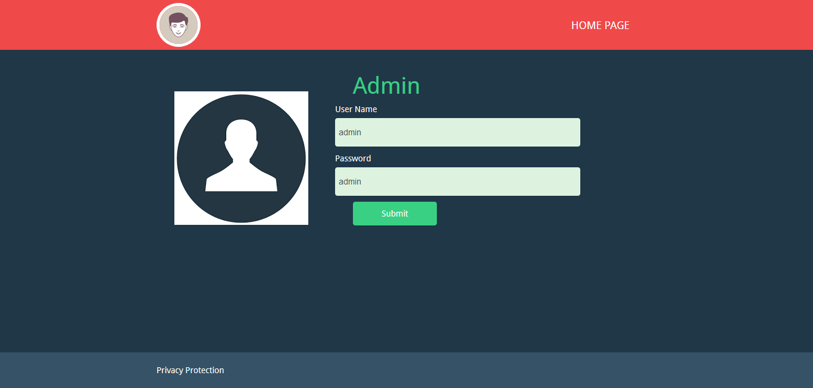

**Add Patient**

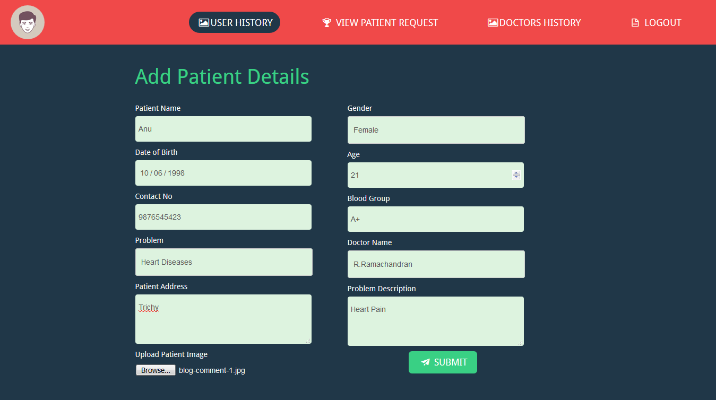

**View patient Details**

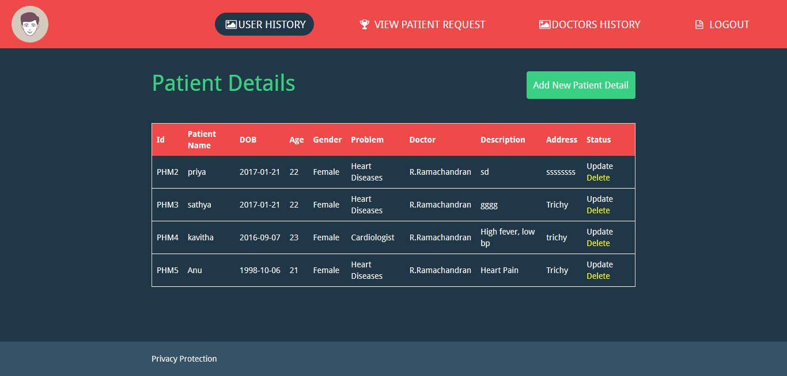

**View Doctor Details**

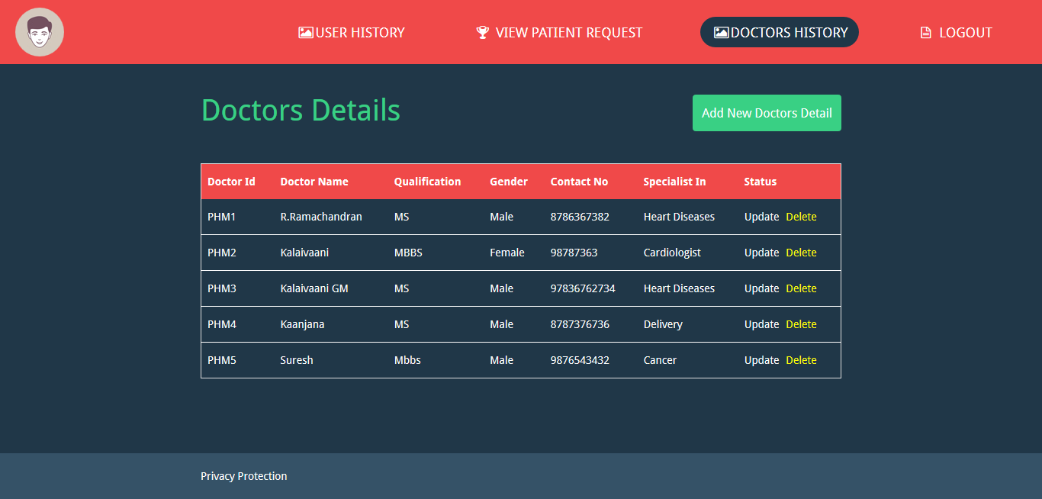

**Patient Request**

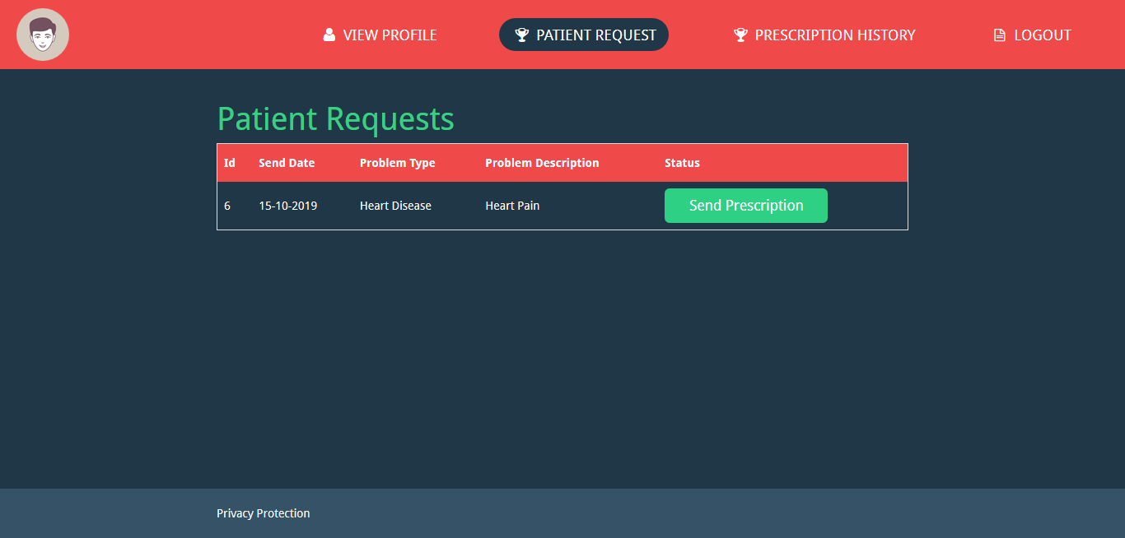

**Patient**

**Login**

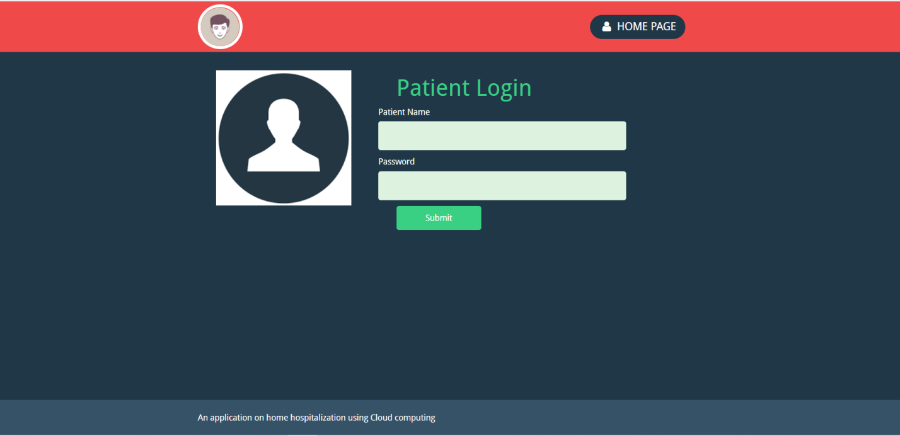

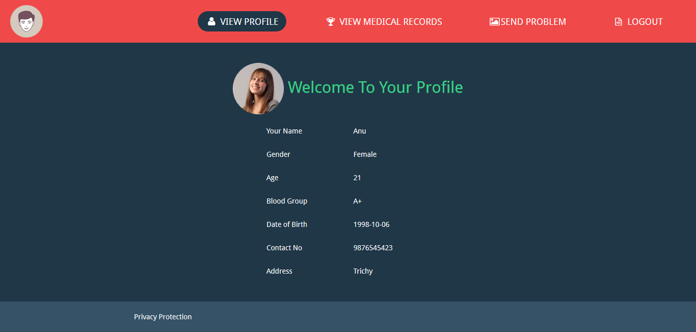

**Medical records**

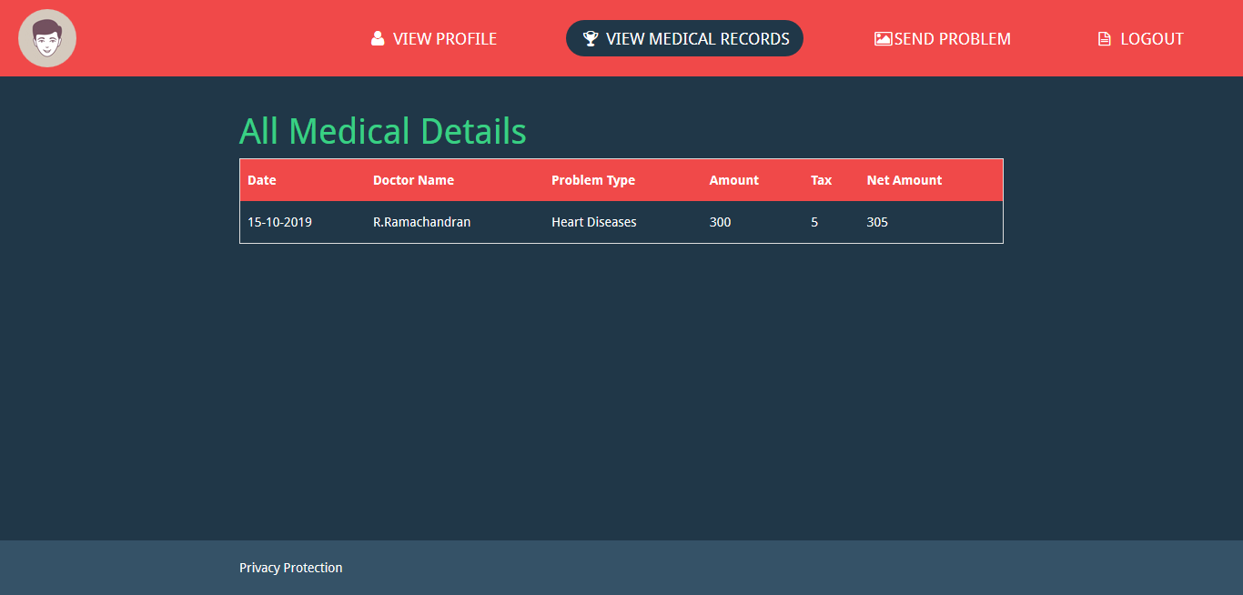

**Send Problem**

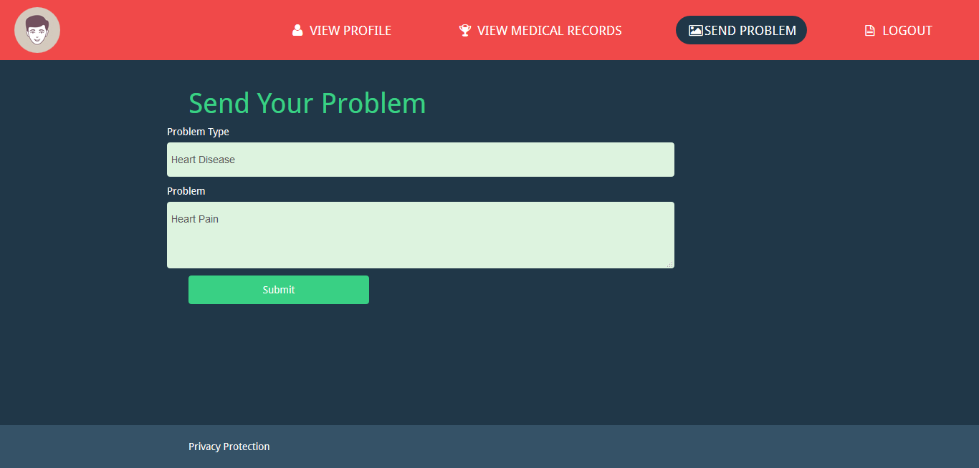

**Doctor**

**Login**

### 

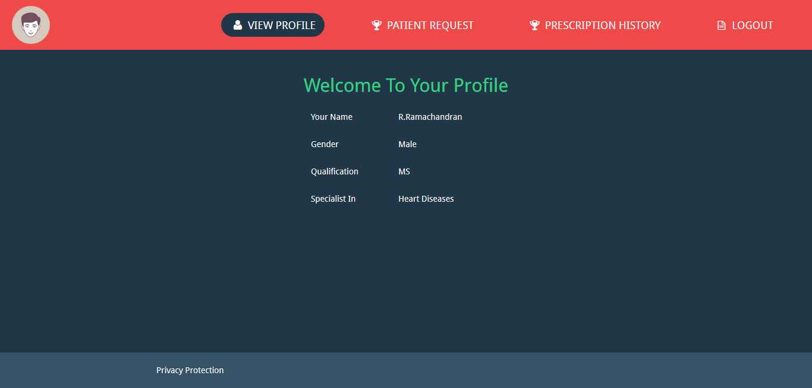

**Patient request**



**Prescription List**

### C:\Users\ilife-07\Downloads\healthcare-screenshot\prescription list.png

### References:

### 1] Ben Hassen H, Dghais W, Hamdi B. An E-health system for monitoring elderly health based on Internet of Things and Fog computing. Health Inf Sci Syst 2019;7: 24–33. <https://doi.org/10.1007/s13755-019-0087-z>.

### [2] Kaur H, Sood SK. Energy-Efficient IoT-fog-cloud architectural paradigm for real-time wildfire prediction and forecasting. IEEE Syst J 2019. https://doi.org/ 10.1109/JSYST.2019.2923635.

### [3] Sun H, Yu H, Fan G, Chen L. Energy and time efficient task offloading and resource allocation on the generic IoT-fog-cloud architecture. Peer-to-Peer Networking Appl 2020;13:548–63.https://doi.org/10.1007/s12083-019-00783-7.

### [4] Rodrigues JJPC, Segundo DBDR, Junqueira HA, Sabino MH, Prince RM, et al. Enabling technologies for the Internet of health Things. IEEE Access 2018;6: 13129–41. https://doi.org/10.1109/access.2017.2789329.